NGO Partner Sample Dataset Collection Steps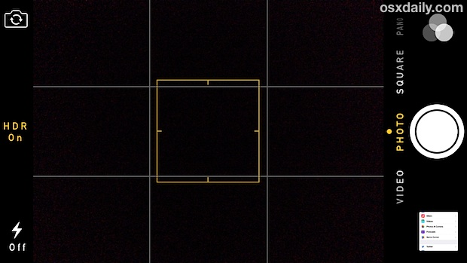

1. Images must be similarly sized, with the food taking up at least the center 1/9 of the image box. A simple way to do this is to use the iPhone or any camera grid function, and to have the food in the image take up at least the center box and extend into the outer eight boxes if possible. However, the food should not completely fill the image frame and should leave some space on the edges. For example, in the grid shown on the right, images would perform best if the center grid square is filled, and the food extends into some of the remaining eight boxes.
2. For different types of ingredients, we would like the food to be positioned and prepared differently for data collection. For all vegetables, fruits, and meats, just one piece of the food should be sufficient for data collection. For grains, the grains should be spread out flat on a flat surface **without** any container for data collection. For liquids such as milk and soups, they should be placed in containers that look as similar as possible for data collection, and then to have the image taken in the same way for other foods.
3. Pictures should be taken from the top-down, preferably with lighting from the top-down as well to minimize shadows. If some shadows are present **not** on the food, that is fine, but we are looking to avoid shadows on the food itself if possible.
4. The background of these images can be changed between pictures, so NGO partners should not worry too much about keeping the background consistent across images.
5. For this first set, we would like to have images of both uncooked ingredients and the cooked results. This way, we can test the performances of our models on both uncooked ingredients and cooked foods to identify which one presents the best solution.